Analytic Geometry – Dilations Quiz

1. Rectangle A’B’C’D’ is a dilation of rectangle ABCD.
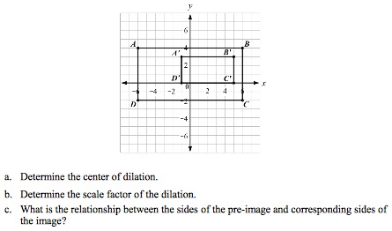

a. (4, 2) – can be found by drawing lines through all pairs of corresponding points.
b. ½. A’B’ = ½ AB.
c. Sides of the pre-image are twice as long as the sides of the image.

2. a. Draw a triangle with vertices A(0, 1), B(-3, 3), and C(1, 3). Dilate the triangles using a scale factor of $\frac{3}{2}$ and a center of (0, 0).
b. Dilate the same triangle using the same scale factor, but a center of (4, -1).
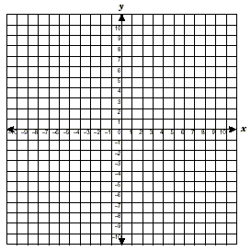
a. A’(0, 1.5), B’(-4.5, 4.5), C’(1.5, 4.5)
b. A’(-2, 2), B’(-6.5, 5), C’(-0.5, 5)

3. Figure A’B’C’D’F’ is a dilation of figure ABCDF by a scale factor of $\frac{1}{2}$. The dilation is centered at (-4, -1).
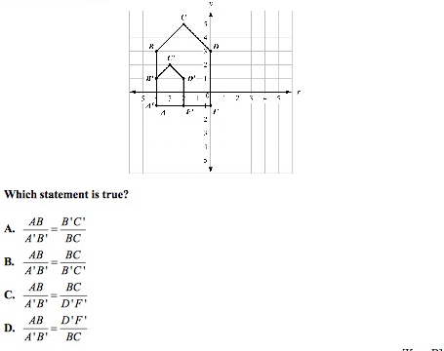

ANSWER: B. Corresponding side lengths are proportional.

