Exploring Solutions by Graphing
Solutions: Answers to this activity can greatly vary. You will have to check to make sure the graphs appear to have the indicated number of solutions. For #3, the linear equation should either appear as tangent to the quadratic, or be a vertical line (but this answer is less likely to appear since creating a perfectly vertical line using a slider in GSP is not possible).
In the last unit, you learned that there are two, one, or no solutions for solving quadratic equations. When you did this, you were essentially solving a system of equations with the equations being the quadratic and the line y = 0.
Now we are solving systems with a quadratic equation and linear equation of the form y = mx + b.
Open the GSP file to explore the different possible outcomes of solving a system of equations with a quadratic and a linear function.
*Note that the equation of the quadratic is set, but you can adjust m and b to get a variety of different linear equations.
Part A
- Slide m and b so that you have two solutions. Sketch the graph you created and indicate where your solutions are on the graph. Record your values of m and b.

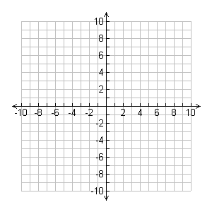

m = ______________
b = _______________

Solutions:
x = ____________
x = ____________

- Repeat #1, but change “two solutions” to “no solutions”.

m = ______________
b = _______________

- Repeat #1, but change “two solutions” to “one solution”.

m = ______________
b = _______________

Solution:
x = ____________

Part B
To verify you are correct in the number of solutions, push the “Intersection(s)” button. This will show you the points of intersection on the graph and the x-values of these points, if there are any. Do this for each of your linear equations in Part A.
Note for #3: If your solutions are within 0.5 of each other, this is close enough to consider it appearing as one point on GSP.

Are there truly two solutions for my system of equations in #1? Yes/No
Are there truly no solutions for my system of equations in #2? Yes/No
Is there truly one solution for my system of equations in #3? Yes/No

If you answered “No” to any of the questions about, adjust your m and b so that you do have the correct amount of solutions.
Record any changes you make below.

