- Write a brief definition of “Trigonometry.”
  - Triangle measure
- Draw a right triangle and label its legs and hypotenuse.
  - Make sure the longest leg is the hypotenuse and it is opposite the right angle
- How do you know which side is the hypotenuse?
  - Longest, opposite right angle
- State the Pythagorean theorem and give a proof of the 45-45-90 triangle measures
  - $c^{2}= a^{2}+b^{2}, but a=b, and c=1 so$
  - $1^{2}=2a^{2}$
  - $\sqrt{\frac{1}{2}}=a$
  - $a= \frac{\sqrt{2}}{2}$

- Write the mnemonic device you prefer to use to remember the trigonometric ratios

- Solve the following right triangles using the Pythagorean Theorem:
12.2 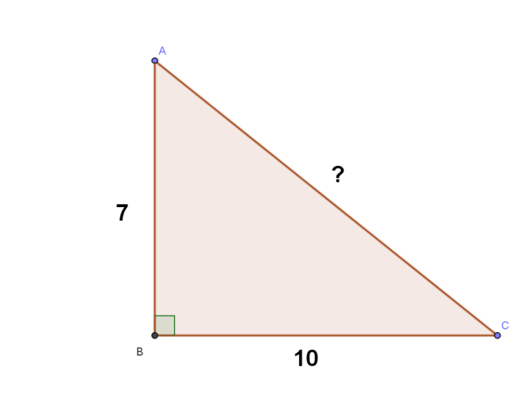 | 9.1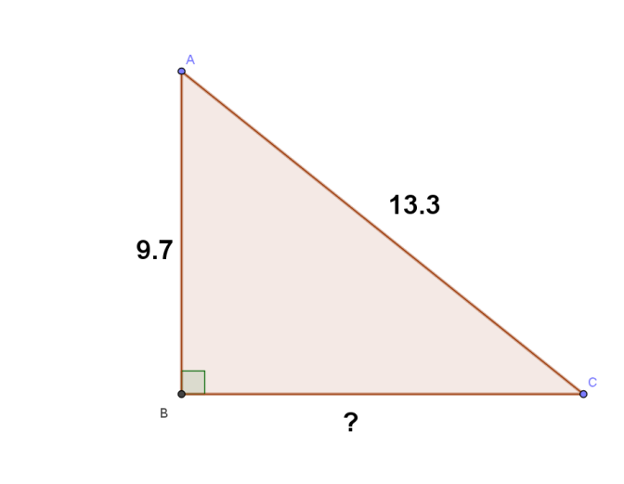
10.6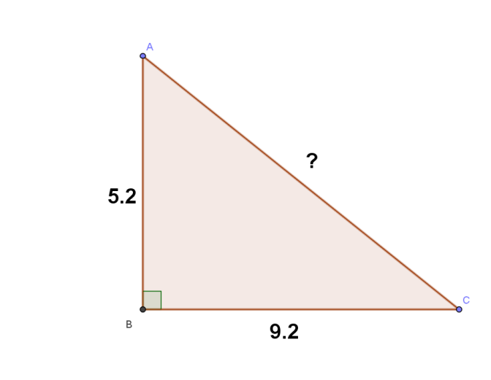 | 7.5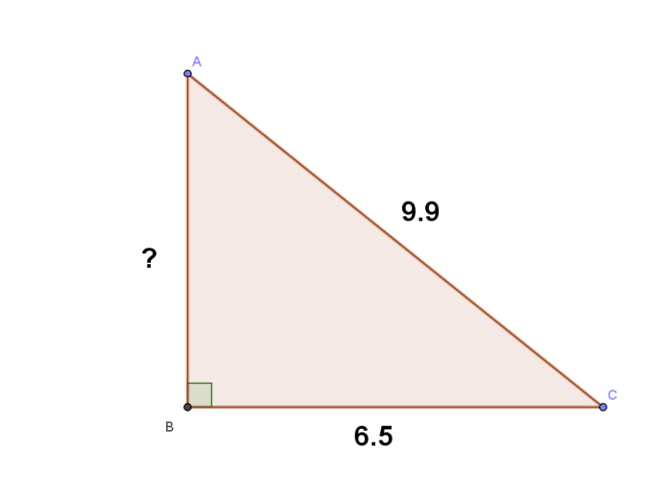

Use your knowledge of special right triangles to solve the following

