- Write a brief definition of “Trigonometry.”

- Draw a right triangle and label its legs and hypotenuse.

- How do you know which side is the hypotenuse?

- State the Pythagorean theorem and give a proof of the 45-45-90 triangle measures

- Write the mnemonic device you prefer to use to remember the trigonometric ratios

- Solve the following right triangles using the Pythagorean Theorem:
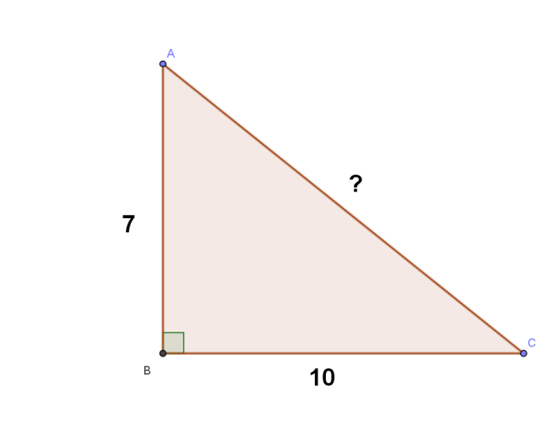 | 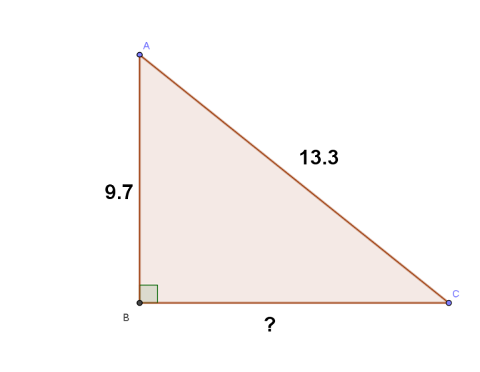
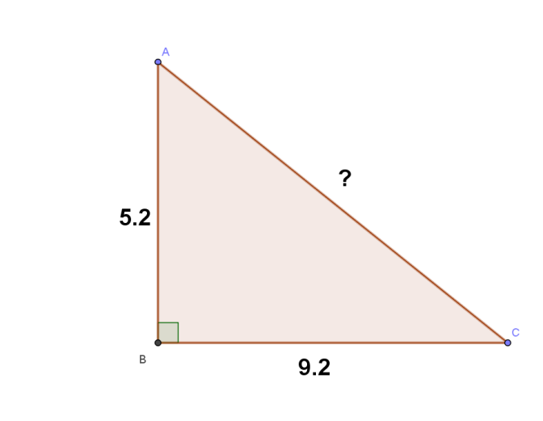 | 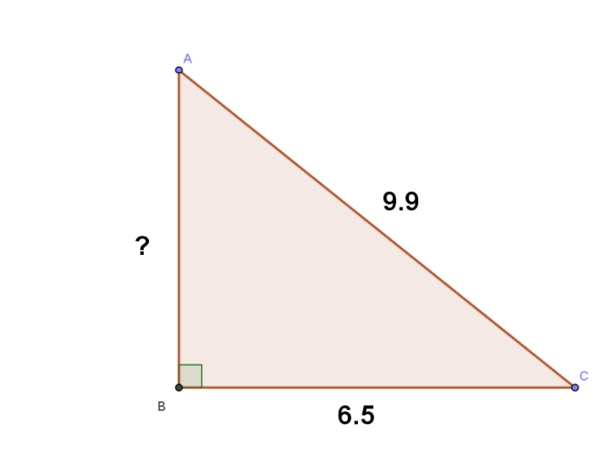

Use your knowledge of special right triangles to solve the following

