- What ratios of angle A are equal to those of angle B?
  - Sin(A) = Cos(B)
  - Sin(B) = Cos(A)
- Form a general definition for each of the ratios using what you have just discovered. Use the terms opposite and adjacent.
  - Sin = O/H
  - Cos = A/H
  - Tan= O/A
- Once you are comfortable with the trigonometric ratios, draw three diffrently oriented right triangles. Give them all different side lengths. Remember which side is supposed to be the longest! Pick one angle on each triangle and find its three trigonometric ratios.
  - Make sure that the students form three well defined right triangles
    - The right angle is apparent
    - The hypotenuse has the greatest length
    - Verify that their ratios are correct
    - Ask them to label the legs and hypotenuse
- Now draw a triangle like the one in the applet above. Imagine that it represents a side of a house with a ladder leaning against it. Label the side of the house, the ground, and the ladder.
  - 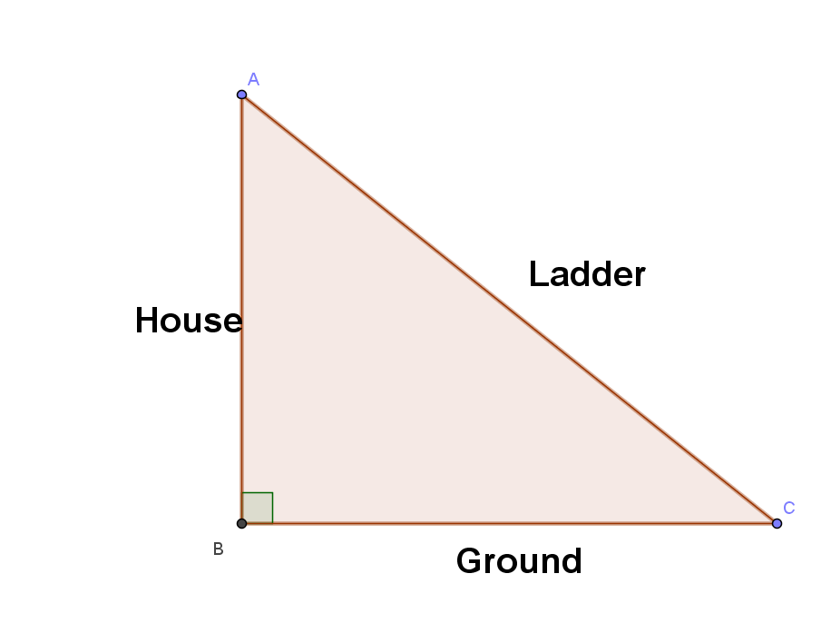
- What would happen if the ladder were shorter than the height of the house?
  - Ask them if they can still form a triangle, and if so, can it have a right angle.
- Could you get to the roof?
  - Students should be aware that the hypotenuse must be longer than the height of the house

